Web Programming Lab - Week 2 - Home Assignment

Name: Srihari Srinivasan

Date: 18/01/2025

Section: C Roll No: 40

Registration Number: 220905326

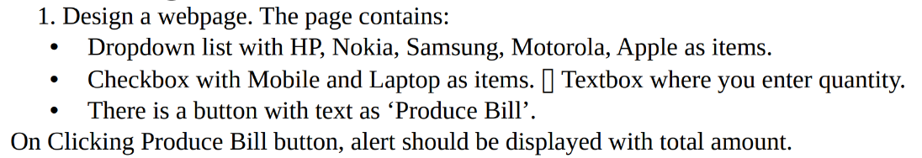

**HTML:**

<!DOCTYPE html>

<html lang="en">

<head>

<meta charset="UTF-8" />

<meta name="viewport" content="width=device-width, initial-scale=1.0" />

<title>Bill Generator</title>

<script src="https://code.jquery.com/jquery-3.6.0.min.js"></script>

</head>

<body>

<h1>Bill Generator</h1>

<form id="billForm">

<label for="brand">Select Brand:</label>

<select id="brand" name="brand">

<option value="HP">HP</option>

<option value="Nokia">Nokia</option>

<option value="Samsung">Samsung</option>

<option value="Motorola">Motorola</option>

<option value="Apple">Apple</option>

</select>

<br /><br />

<label>Items:</label><br />

<input type="checkbox" id="mobile" name="item" value="Mobile" />

<label for="mobile">Mobile</label><br />

<input type="checkbox" id="laptop" name="item" value="Laptop" />

<label for="laptop">Laptop</label><br /><br />

<label for="quantity">Enter Quantity:</label>

<input

type="number"

id="quantity"

name="quantity"

min="1"

required

/>

<br /><br />

<button type="button" id="produceBill">Produce Bill</button>

</form>

<script>

$(document).ready(function () {

$("#produceBill").on("click", function () {

const brand = $("#brand").val();

const items = [];

$('input[name="item"]:checked').each(function () {

items.push($(this).val());

});

const quantity = $("#quantity").val();

if (items.length === 0) {

alert("Please select at least one item.");

return;

}

if (!quantity || quantity <= 0) {

alert("Please enter a valid quantity.");

return;

}

const totalAmount = items.length * quantity * 100; // Assuming each item costs $100

alert(

`Brand: ${brand}\nItems: ${items.join(

", "

)}\nQuantity: ${quantity}\nTotal Amount: $${totalAmount}`

);

});

});

</script>

</body>

</html>

**OUTPUT:**

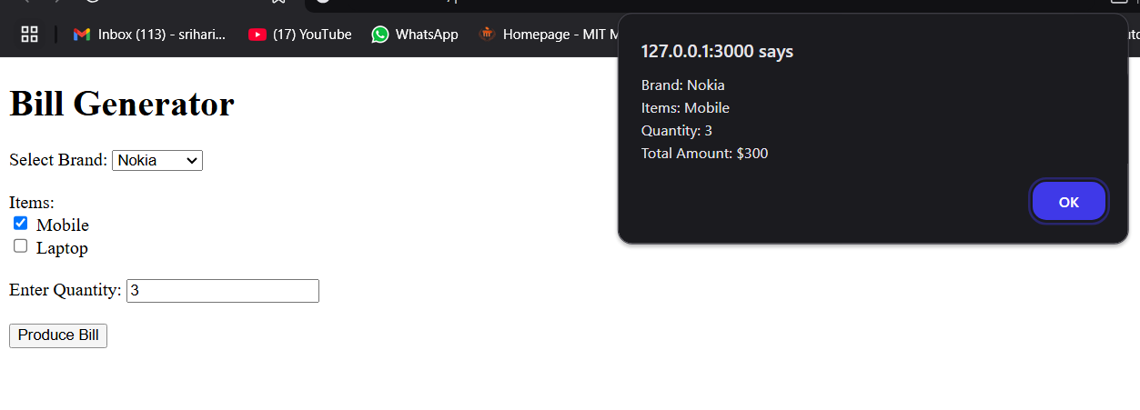



**HTML:**

<!DOCTYPE html>

<html lang="en">

<head>

<meta charset="UTF-8" />

<meta name="viewport" content="width=device-width, initial-scale=1.0" />

<title>Bouncing Ball</title>

<script src="https://code.jquery.com/jquery-3.6.0.min.js"></script>

<style>

body {

display: flex;

justify-content: center;

align-items: center;

height: 100vh;

margin: 0;

background-color: #f0f0f0;

overflow: hidden;

}

#container {

position: relative;

width: 500px;

height: 400px;

border: 2px solid #000;

background-color: #fff;

overflow: hidden;

}

#ball {

position: absolute;

width: 50px;

height: 50px;

background-color: red;

border-radius: 50%;

top: 0;

left: 50%;

transform: translateX(-50%);

}

</style>

</head>

<body>

<div id="container">

<div id="ball"></div>

</div>

<script>

$(document).ready(function () {

function bounceBall() {

// Animate the ball downwards

$("#ball").animate(

{ top: "350px" },

1000,

"linear",

function () {

// Animate the ball upwards

$("#ball").animate(

{ top: "0px" },

1000,

"linear",

bounceBall // Call the bounceBall function again for a continuous bounce

);

}

);

}

bounceBall(); // Start the animation

});

</script>

</body>

</html>

**OUTPUT:**

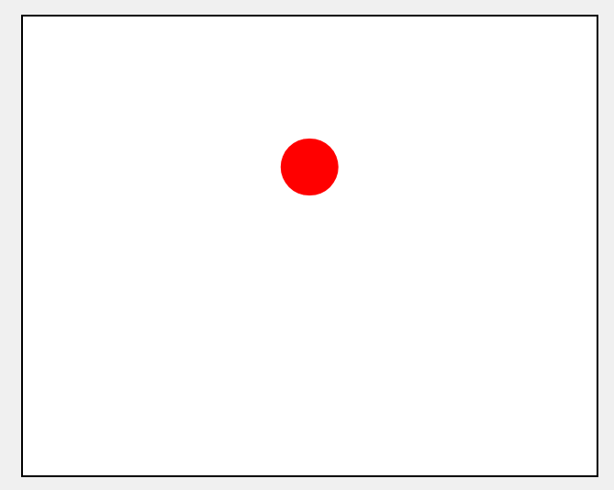



**HTML:**

<!DOCTYPE html>

<html lang="en">

<head>

<meta charset="UTF-8" />

<meta name="viewport" content="width=device-width, initial-scale=1.0" />

<title>Sliding Text on Image</title>

<script src="https://code.jquery.com/jquery-3.6.0.min.js"></script>

<style>

body {

margin: 0;

padding: 0;

display: flex;

justify-content: center;

align-items: center;

height: 100vh;

background-color: #f0f0f0;

}

.image-container {

position: relative;

width: 600px;

height: 400px;

overflow: hidden;

}

.image-container img {

width: 100%;

height: 100%;

display: block;

}

.sliding-text {

position: absolute;

bottom: 0;

left: -100%;

width: 100%;

text-align: center;

color: white;

font-size: 24px;

font-weight: bold;

background: rgba(0, 0, 0, 0.6);

padding: 10px;

box-sizing: border-box;

}

</style>

</head>

<body>

<div class="image-container">

<img src="cherryblossom.jpg" alt="Sample Image" />

<div class="sliding-text">Welcome to the Sliding Text</div>

</div>

<script>

$(document).ready(function () {

function slideText() {

$(".sliding-text").animate(

{ left: "0%" },

1000,

function () {

$(this)

.delay(2000)

.animate({ left: "-100%" }, 1000, slideText);

}

);

}

slideText(); // Start the sliding animation

});

</script>

</body>

</html>

**OUTPUT:**

